
ACTIVITY REPORT
ON
GRANDMASTER’S GAMBIT 3.0
- Name of the Club: BMSCE ACM STUDENT CHAPTER
- Name of the Activity: GRANDMASTER’S GAMBIT 3.0
- Objectives: The tournament aims to promote strategic collaboration and adaptability in competitive chess by bringing together teams of two players. Unlike traditional solo play, this team-based format emphasizes coordination, communication, and joint decision-making across a series of varied chess formats.
By challenging players with different styles of play, the event seeks to identify the most well-rounded and cohesive team. Success will depend not only on individual skill but also on a team’s ability to adapt, strategize together, and perform under pressure.
- Date, Time Venue of the Activity:
EVENT | GRANDMASTER’S GAMBIT 3.0
DATE/DAY | Sunday, 11th May, 2025
TIME | 9:00 am to 4:00 pm
VENUE | AIML LAB 1
- Name and details of collaborating agency (if it is collaborative/joint activity): None
- Brief summary of the Event:
An Exciting Team Chess Tournament on Chess.com!
Grandmaster’s Gambit 3.0, hosted on Chess.com, was a thrilling and fast-paced online chess experience like no other. This unique event brought a refreshing twist to traditional chess competitions by focusing on team-based play. Each team consisted of two players who joined forces, combining their skills, strategies, and communication to outplay their opponents.
The tournament featured a series of matches played in multiple chess formats, including blitz, bullet, and rapid games. This variety tested each team’s adaptability and versatility, pushing players to think quickly, plan effectively, and adjust their playstyles depending on the format and opponent. No two matches were the same — making every round a new challenge and an opportunity to shine.
Teamwork was at the heart of this competition. Success depended not just on individual skill but also on how well players communicated, supported, and synchronized with each other. Whether it was discussing opening strategies, coordinating attacks, or defending in tough positions, teams had to stay sharp and stay united throughout the event.
At the end of the tournament, the team with the most overall victories across all games and formats was declared the champion. Along the way, there were thrilling plays, surprising upsets, and memorable moments of collaboration and creativity.
Whether it was tactical brilliance, fast thinking, or dynamic coordination, this tournament became the perfect stage for participants to showcase their passion for chess and their strength as a team.

- Outcomes:
The event is designed to deliver an engaging and challenging experience that goes beyond traditional individual chess play. By incorporating a variety of game formats and requiring close coordination between teammates, the tournament will showcase the value of strategic collaboration and adaptability under pressure.
Participants will walk away with enriched skills in communication, rapid decision-making, and tactical planning across different time controls and styles of play. The event will also strengthen the sense of community among chess enthusiasts by fostering sportsmanship, mutual respect, and camaraderie through team-based competition.
Ultimately, the tournament will crown a champion team that not only excels in individual talent but also demonstrates exceptional synergy and versatility. This outcome will serve as a celebration of both strategic excellence and cooperative gameplay in the evolving landscape of online chess.

- Number of participants:
Number of Participants | Number of Volunteers
32 | 6

- Photographs of the event:
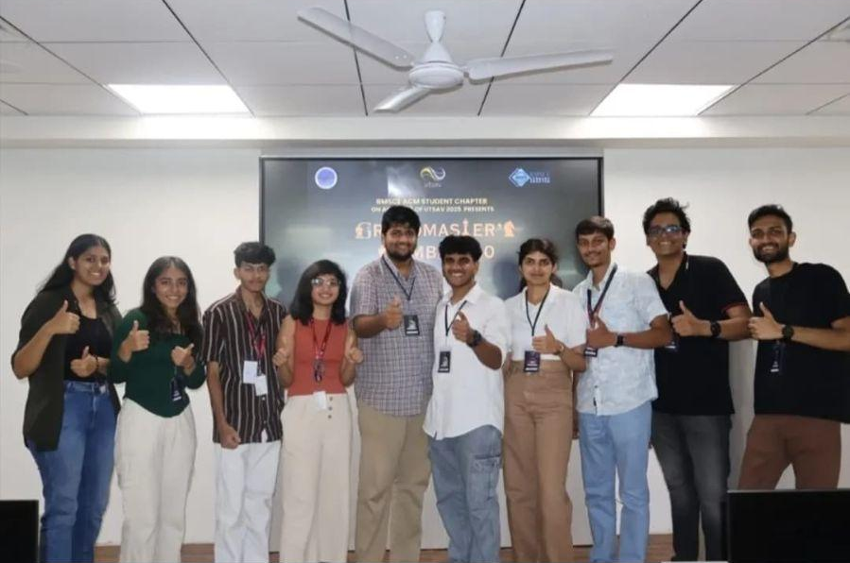
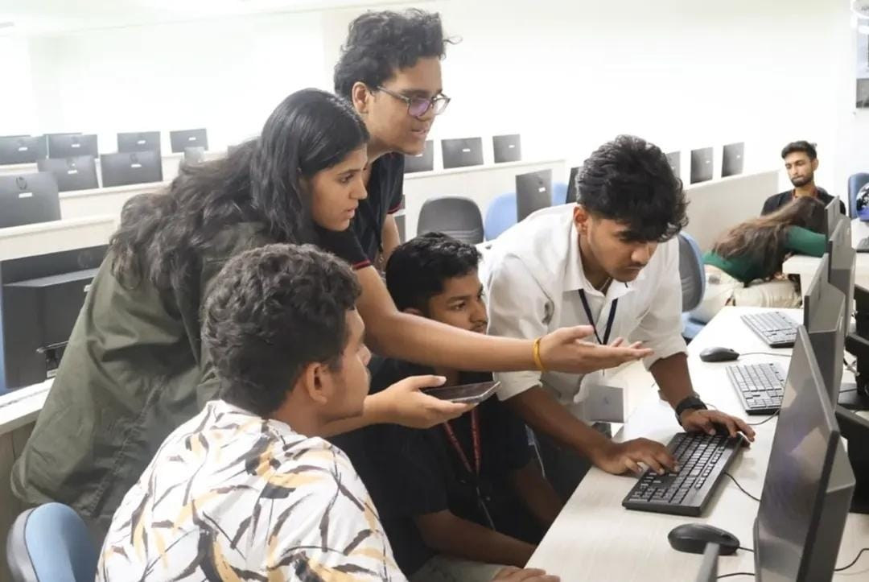
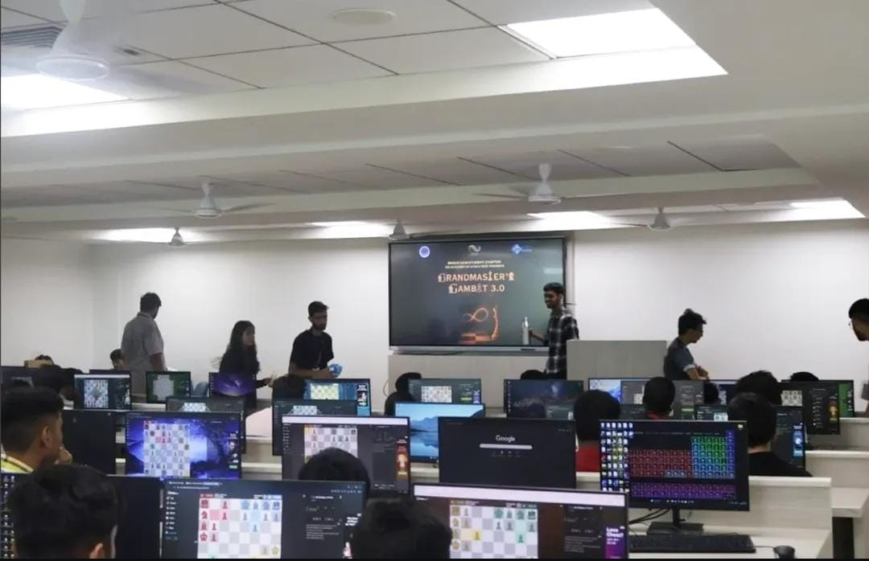
- Supporting Documents:
a. Circulars/Brochures:

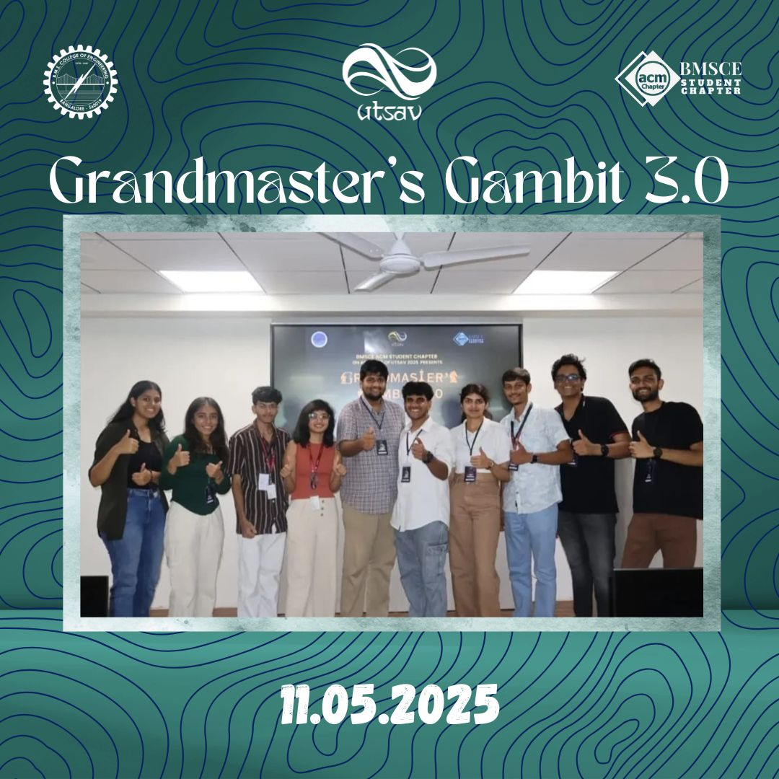
b. Attendance:
M G Prameeth - prameetraj@gmail.com
Akshay Bhat - akshaybhat.ai24@bmsce.ac.in
Harsh Kothari - harshkothari20022005@gmail.com
Mounish Reddy - csmr1302@gmail.com
Gautham A Bhargav - gggaming12453@gmail.com
Pranjal - 1308pranjal@gmail.com
K Thulasi Reddy - reddythulasi500@gmail.com
Aniketan Shetty - aniketanshetty@gmail.com
M Afnan Ali - afnaanaligvt2601@gmail.com
Dheemanth Dhoopad - praneethnrig@gmail.com
Aryan Sagar Vishwa - aryansagar2006@gmail.com
Poornima Talawar - prtalawar11@gmail.com
Pramath KS – ushaks609@gmail.com
Dhruva Acharya N - dhruvaacharya.cs24@bmsce.ac.in
Thushar K - thushark235@gmail.com
Prateek Raghavendra - pra.4sr@gmail.com
Chaitanya Uma Shankar - chaitanyaumashankar280@gmail.com
Pranav Mohan - mohanpranav65@gmail.com

